

September 29, 2018
English Worship Experience
11:15 am

Ministry News |  |  |  |  |  | Pastor Marc Woodson
Welcome |  |  |  |  | Pastor Marlene Rodriguez
Praise & Worship | “He Lives” Hymn #251  “Power in the Blood” Hymn #294  “Praise Him, Praise Him” Hymn #249 |  |  |  |  |  |  |  |  |  | Congregation
Tithes & Offerings |  |  | Impact Pacific Union |  |  |  |  |  | Pat Dorais
Congregational Prayer |  |  |  |  |  |  |  | Claudine Metuge
Scripture Reading |  |  |  | Acts 1:6 - 8 |  |  |  | Abigail Taku
Sermon |  |  |  | “Where Do We Go  From Here?” |  |  | Pastor Marlene Rodriguez
Closing Song |  | “Amazing Grace” Hymn #108 |  |  |  |  |  |  |  | Congregation
Blessing |  |  |  |  |  |  | Pastor Marlene Rodriguez

Welcome to Concord International! Also known as CISDAC. We are multicultural, multilingual and multiethnic church. We would like to think that we represent what God’s kingdom looks like. But God’s kingdom is not known just as people from all nations and languages, but also as disciples who reflect God’s character through our own lives. My prayer is that you come to know Jesus better today than you knew Him before. – Pedro M Trinidad, Pastor

Deacons of the Day: Raul Nogueda & Rafael Faustino
Elder on duty: Angel Johnson

Sabbath Rest is until 6:53 pm on September 29
Next Sabbath’s welcome is at 6:44 pm on October 5

Announcements

- United Fellowship Lunch – Today after the church service in the Fellowship Hall. All guests are invited to stay. We'd love for you to stay and get to know you a little better.

- Sabbath School Teacher’s Meeting – Today after potluck in the Sanctuary.

- Sabbath School – Oct. 6 at 10:00 am. Come for a discussion on a new lesson study “Oneness in Christ” – Lesson 1 “Creation and Fall.” We meet in the church sanctuary.

- Women’s Ministry Bible Study & Fellowship Lunch – Oct. 6 Following the church service at Gilda Leiva’s home at 1912 Jacqueline Way, Concord. Notice – change to 1st Sabbath this month. All ladies are welcome to join us!

- Adventurer Club Meeting – Every 1st and 3rd Sabbath each month. We meet in the Primary classroom from 2:00 – 3:30. See Keila for more info.

- Church Workbee - Oct. 7 at 9:00 am. Our work will be focused on 3 main projects. 1) Replace the fence at the rear entrance. 2) Repair concrete roof tiles; 3) Remove pine needles from roof in preparation for the rainy season. This is in addition to the regular cleaning done at workbees. If you have any experience in doing any of these particular jobs please contact our Facilities Manager, Roger Davila (925) 698-1937.

Events At-Large

Pleasant Hill Adventist Academy Events and Invitationals
- Oct. 3: Road to Graduation, College Financial Aid Workshop, 6:30 pm, Library (All High School age juniors and seniors along with parents are welcome to join us!)
- Oct. 14: Fall Festival, at PHAA, 10:00 -2:00 pm, join us for great music, food, and games. “We Are the World” is our Fall Fest theme and you won’t want to miss this great community event!

The Week at a Glance

Wednesday: Spanish Prayer Meeting in the Fellowship Hall at 7:30 pm
Thursday: Join a small group Bible Study at 7:00 pm at Celia & Sonny Regal’s home,
1792 Mariposa Ct., Concord, as they read and study the book of Luke. All are welcome!
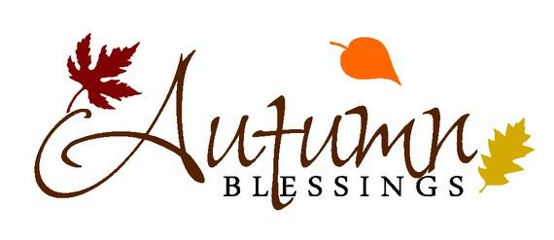
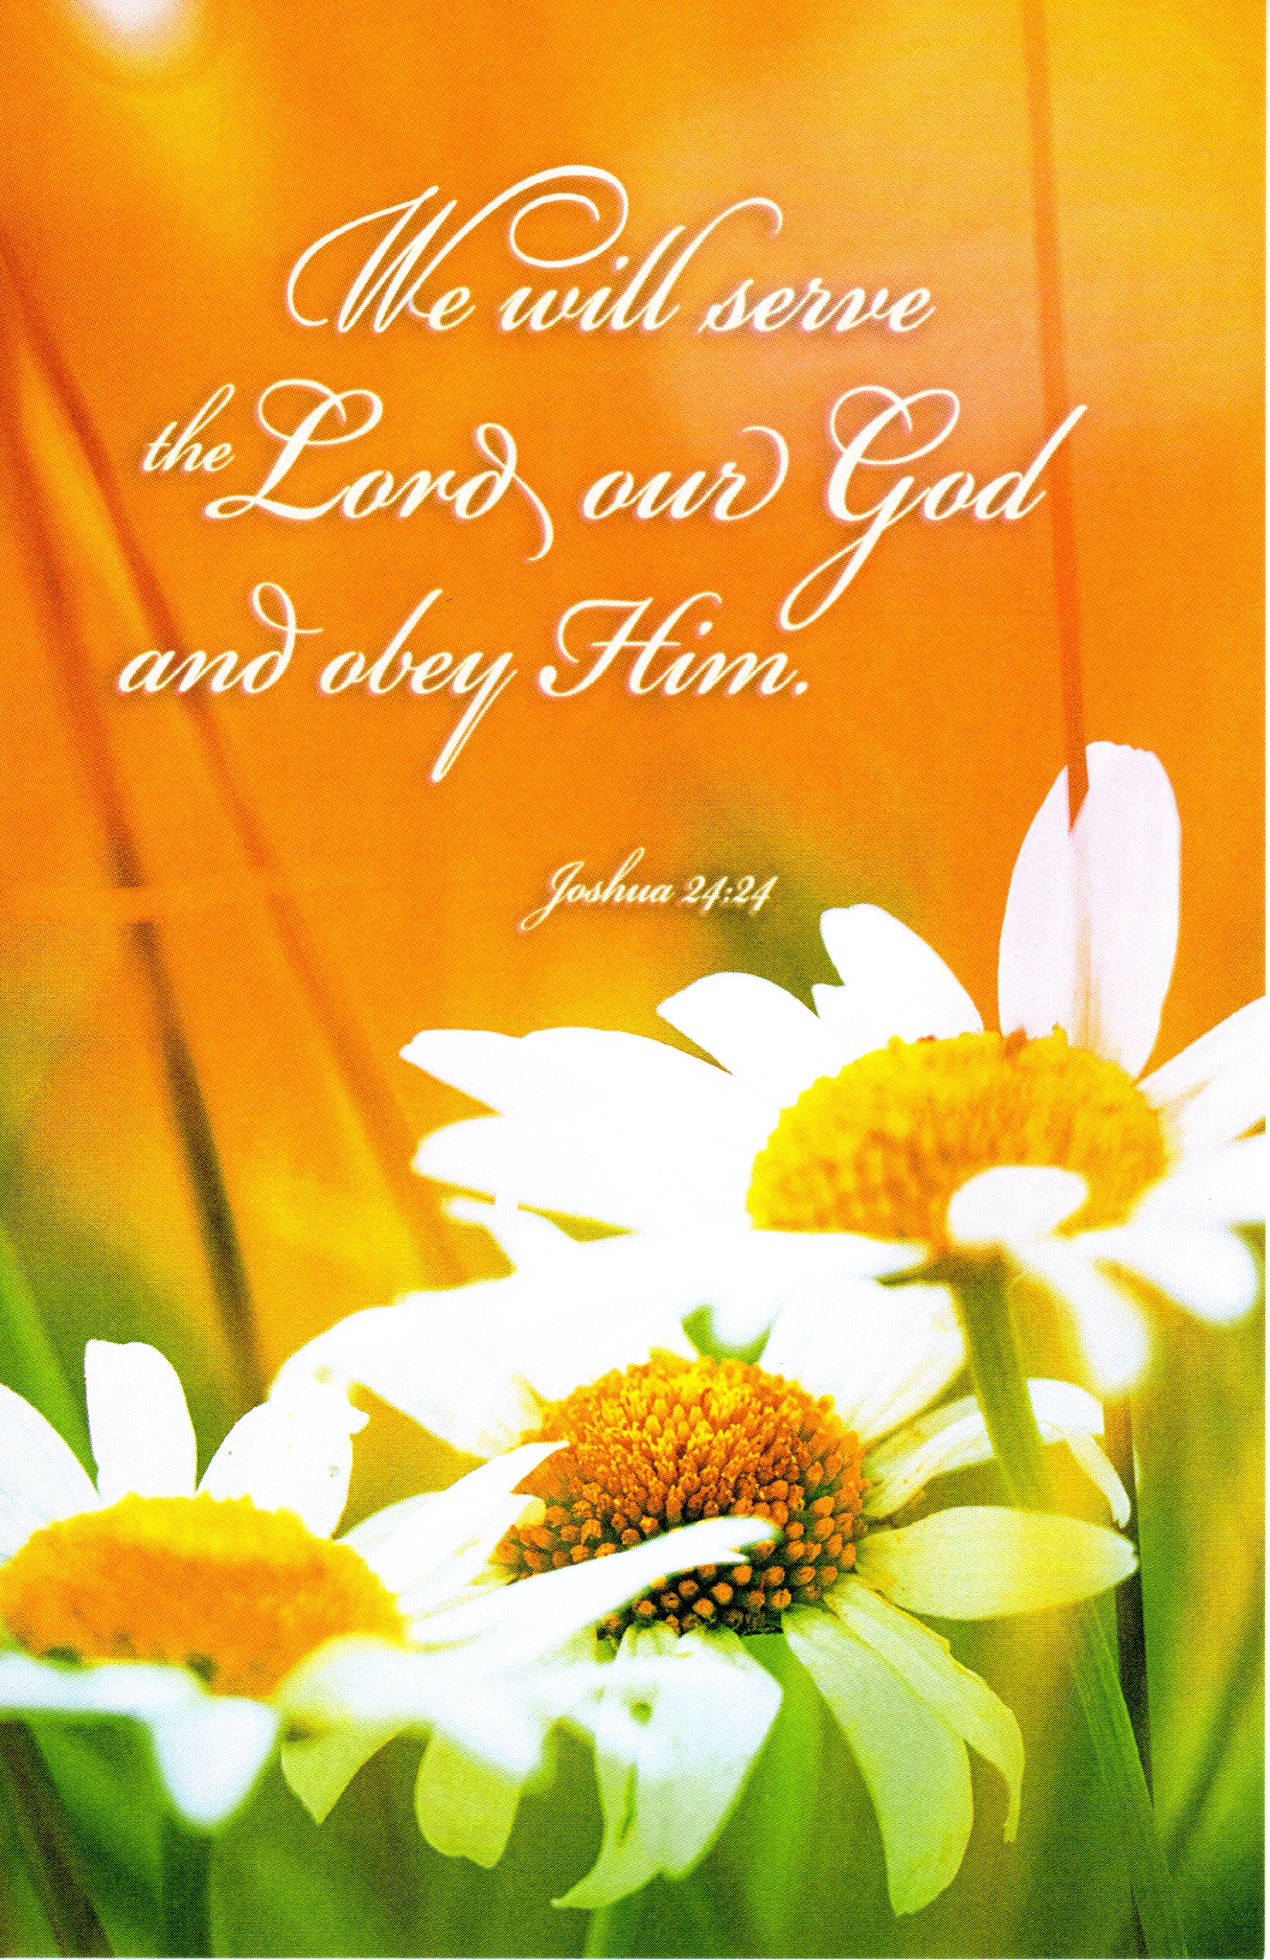
Connect Cards

Connect Card is a way of letting the pastor know that you would like a visit, a phone call, a prayer request, or you would like to communicate some other information. These cards can be found in the pews. If you are visiting us today, we invite you to fill the card with as much information as you want to give and put it in the offering plate as the offering is being collected.

Church Vision

A growing, united, friendly, outreach-driven congregation, where all members are known and use their gifts to better the church and the community.

Mission

Building a Christ-centered, warm, empowered, and united community that is outreach-driven.
Sick & Shut-in
Albert (Al) Hamra is at the Emerald Care Home, 113 Rock Oak Court, Walnut Creek, CA 94598. He is requesting visitors.

Follow us on Social Media




cisdac_inaction
concordinternational
@cisdac
cisdactv

Our Website - www.concordinternationalsda.org

Concord International Seventh-day Adventist Church
1655 West Street, Concord, CA 94521
(925) 676-4111 secretary@concordinternationalsda.org
(925) 951-7041 leadpastor@concordinternationalsda.org

Pastors
Pedro M. Trinidad, Lead Pastor
Menwagaw A Neguise, Associate Pastor
Marlene Rodriguez, Associate Pastor
Dr. Marc Woodson, Associate Pastor
Mario Sequeira, Elder
Hilario Freitas, Elder
Eduardo Fagundes, Elder
Angel Johnson, Elder

